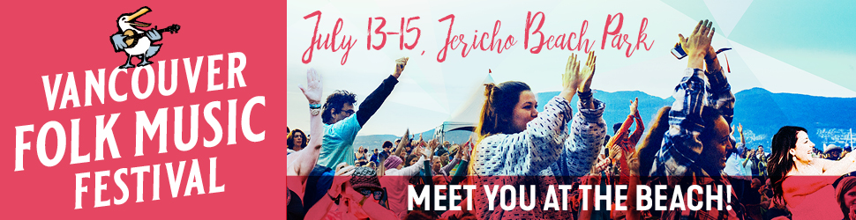
Media Contact: Gwen Kallio | 604-215-2345 | 778-245-4936 | sisuproductions@telus.net

Vancouver Folk Music Festival
COMING UP SOON!
July 13-15, 2018
Jericho Beach Park, Vancouver, BC
Info & tickets: www.thefestival.bc.ca / 604-602-9798

PHOTOS: are available for download from the festival's website under the "Media" tab
THE FULL FESTIVAL LINE UP IS BELOW and online HERE.
Festival Weekend Schedules are online HERE.

June 22, 2018 - Vancouver, BC, Canada: The 41st Vancouver Folk Music Festival is coming soon, and all systems are tuned up and ready to go!

The 2018 festival lineup is an exciting, musically rich and eclectic roster of over 50 acts, presenting music with origins in over a dozen countries, with artists coming from Europe, Africa, North, Latin and South America and Australia – including from numerous Canadian provinces and territories, and US states. It’s a stunning slice of global music and culture, featuring everything from folk, Americana, bluegrass and blues to son jarocho, marrabenta, mariachi, Quebecois and Cajun, to Ukrainian folksong and ancient Moravia melody. The diversity is stunning – the opportunity to discover is unlimited. The full list of 2018 performers is below in alphabetical form, and more information on each of these artists is available on our website by clicking: http://thefestival.bc.ca/2018-artists/

Over 35,000 enthusiastic music fans are expected to fill Jericho Beach Park, one of the world’s most beautiful urban festival sites, to experience the special magic of this annual community gathering of musical adventurers over festival weekend.

On the weekend, starting at 4pm on Friday afternoon, July 13, festival-goers will be treated to an array of concerts and workshops on five daytime and two evening stages. The evening Main Stage concerts, a brilliant showcase featuring some of music’s brightest lights, run from 6-11pm Friday, Saturday and Sunday. Main Stage artists performing each night are*: FRIDAY – Darlingside, Three Women & the Truth, James McMurtry, Neko Case | SATURDAY – Kacy & Clayton, DakhaBrakha, Rodney Crowell, The Dead South | SUNDAY – Jayme Stone’s Folklife, Wazimbo & Banda Kakana, Ranky Tanky, Ry Cooder featuring The Hamiltones.

The Twilight Stage (Stage 3) offers a range of concert options each night as well, from around 6 to 9pm.

From 4pm to 6pm on Friday, and from 10am to 6pm on Saturday and Sunday, five Daytime Stages located around the park site offer up over 50 concerts and workshops. “Workshops” are collaboratory gatherings of two or more artists and groups who come together to share music and songs with each other and the audience around particular themes or subjects. The beating heart of the festival experience, these “you have to be there live” experiences often spark the most memorable moments of the weekend.

The full schedule of Main Stage, Twilight Stage and the five Daytime Stage performances can be found online on the festival website at: http://thefestival.bc.ca/2018-weekend-schedule/

In addition to the great music, there are a wide range of Food and Artisan vendors on site along with a Folk Bazaar along the beachfront, the Big Rock Beer Garden, the Little Folks Village full of activities and entertainments for the whole family, the Community Village, where local non-profit organizations share their mission and work, and CD and Merchandise sales. The festival prides itself on its environmental and sustainability initiatives, and on making the festival accessible – and lots of fun. Around 1400 volunteers help to make the festival a success. There is ample bike parking on site, and visitors are encouraged to bike, walk, or take transit rather than drive to the festival. No bottled water is sold on site – audience members are asked to bring their own bottles - and water refill states are located around the site.

Tickets are available for adults, with discounts for elders, students and youth. Children 12 and under are free.
Folks can purchase single day tickets or full weekend passes.
An adult all-weekend pass is $170 till July 12, and $185 at the gate.
Group ticket discounts are available.
The full ticket details can be found at: http://thefestival.bc.ca/ticket-information/

Full festival information is at: www.thefestival.bc.ca

Follow the VFMF on social media:
Facebook: https://www.facebook.com/VanFolkFest | Handle: @VanFolkFest
Twitter: https://twitter.com/vanfolkfest | Handle: @VanFolkFest
Instagram: https://www.instagram.com/vanfolkfest/?hl=en | Handle: @VanFolkFest
Festival Hashtag (Facebook, Twitter, Instagram): #VFMF2018

* subject to change without notice
*VFMF 2018 Performer Lineup (UPDATED)
Art Bergmann (AB)
Wallis Bird (Ireland)
Mariel Buckley (AB)
Steph Cameron (BC)
Neko Case (VT)
Joachim Cooder (CA)
Ry Cooder featuring The Hamiltones (CA)
Rodney Crowell (TN)
Alex Cuba (BC |Cuba)
DakhaBrakha (Ukraine)
Dálava (BC)
Darlingside (MA)
Guy Davis (NY)
The Dead South (SK)
Las Estrellas de Vancouver (BC | Mexico)
Mick Flannery (Ireland)
Dori Freeman (BC)
Gamelan Bike Bike (BC)
Ilaria Graziano & Francesco Forni (Italy)
Gordon Grdina’s Haram (BC)
Jimmy “Duck” Holmes (MS)
Iskwé (MB)
Kacy & Clayton (SK)
Martin Kerr (AB)
Ezra Kwizera (BC | Rwanda)
Grant Lawrence & Friends (BC+)
Little Miss Higgins (MB)
John Lowell Band (MT)
A Familia Machado (BC & Brazil)
James McMurtry (TX)
Mike Munson (MN)
Murfitt & Main (BC)
Dawn Pemberton (BC)
Petunia & the Vipers (BC)
Carole Pope (ON)
Les Poules à Colin (QC)
Professor Banjo & Estro Jennies (BC)
Quantum Tangle (NU)
Ranky Tanky (SC)
Steve Riley & the Mamou Playboys (LA)
Archie Roach (Australia)
The Small Glories (AB)
Son de Madera (Mexico)
Jayme Stone’s Folklife (ON)
Leonard Sumner (MB)
Three Women and the Truth (TX)
Viper Central (BC)
Skye Wallace (BC)
Wazimbo & Banda Kakana (Mozambique)
Donovan Woods (ON)

Please note: originally announced Argentinean artist, Melingo, has unfortunately had to cancel.

PHOTOS: are available for download from the festival's website under the "Media" tab on the festival website.
MEDIA ACCREDITATION REQUESTS can be made by filling out the form under the "Media" tab on the festival website.

Media Contact:
Gwen Kallio
Office direct: 604-215-2345
Mobile: 778-245-4936
sisuproductions@telus.net

